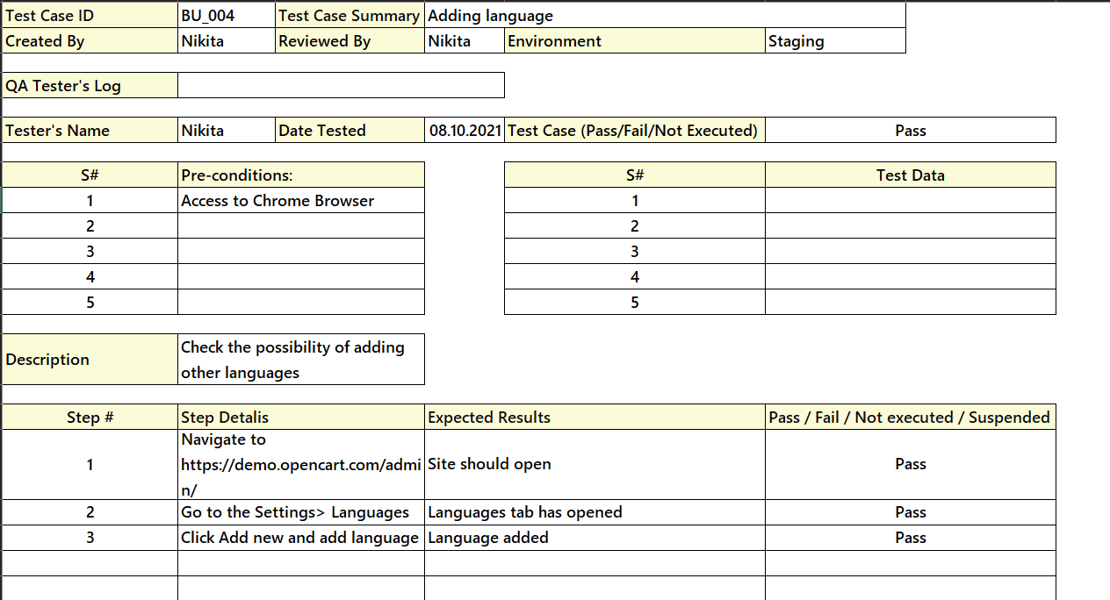

For the fourth test case, the design technique is causal. That is, when you enter all the language data (reason), a new tab with the language (consequence) is created.